OUR ENVIRONMENT
As a coastal community we have “visitors” that not all communities get to enjoy. Winter brings Canada and snow geese as well as the occasional Tundra Swan. In recent winters, a Snowy Owl has been appearing, and every season Bald Eagles are being spotted. The warming days of April give the baby diamondback terrapins (about the size of a half dollar coin) a reason to emerge from our beach and cross Bay Avenue. Please, if you see these babies in the yard or on the street, move them to the safety of the marsh.
If you happen across an adult terrapin, you can help it cross the road in the direction it was heading, but don't make that effort with the large snapping turtles that frequent Slaughter Beach Road - their name is reason enough. May and June delight us with the spawning season of the Horseshoe Crab. These creatures are our mascot and while they look menacing, they are docile. If you see one on its back, gently flip it over, but never by its tail.
Shorebirds flock to the area, especially Red Knots, to feast and fatten up on the Horseshoe Crab eggs - and the Purple Martins and Hummingbirds appear in full force.
Dolphins and Cownose Rays frolic offshore during the summer months. Fall shows us the migration of the Monarch butterflies across the bay.
Slaughter Beach has been recognized as a Certified Wildlife Habitat since May of 2015 and we are working to naturalize our surroundings to help the Monarch population, and other wildlife, grow and thrive.
Wendell Berry, 1971
…A man knows that the world is not given by his fathers, but borrowed from his children…
GUIDELINES FOR SAFE FUN

DRIVING
The speed limit through town is 25 mph, until you get to the north end where it increases to 35 mph. Please watch our children.
We have many but can’t spare any.

SWIMMING
Swim with other people - at your own risk!
There are no lifeguards.

BOATING
Boat a safe distance from shore. Consider water depth and low tide.

JET SKIS
Ride jet skis a minimum of 100 feet from swimmers, shore, non-motorized boats, and anchored boats.

PETS
Keep your dogs leashed and under your control. Remove pet waste and dispose of properly.

FIRES ON THE BEACH
Only residents of the Town of Slaughter Beach are allowed to build fires on the beach; check wind force and direction as well as burn bans before attempting. Keep fire below dunes and extinguish fully by covering with sand. Do not leave unattended. Visit: https://dnrec.alpha.delaware.gov/air/open-burning

DUNES
Enjoy strolling the beach looking for special treasures but please stay off the dunes/beach grass as they are fragile and are the first line of protection from flooding.
https://slaughterbeach.delaware.gov Please always leave with what you brought so that all visitors will experience nature without

the extras that people and pets leave behind.
WELCOME
to
SLAUGHTER BEACH
Horseshoe Crab Sanctuary since 2004
A Certified Wildlife Habitat Community since 2015
Established: 1681
Incorporated: 1935
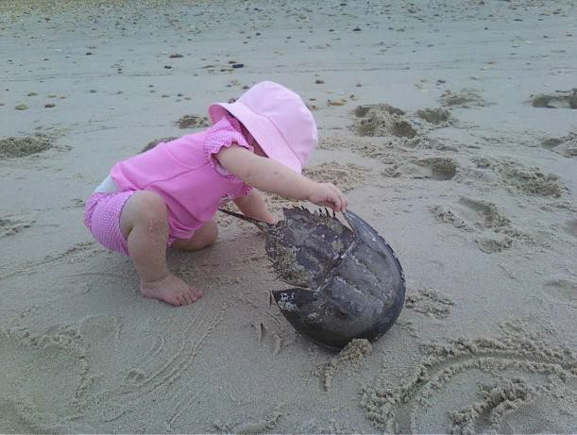
We are a small coastal community with great pride and love for our surroundings. There is a laid-back feel to living here. Kids play outside, neighbors wave to each other. Our love of the water and unspoiled nature draws us and keeps us here. Each season brings its own surprises, from Snowy Owl sightings in winter to Horseshoe Crab spawning and Dolphins playing offshore in late spring and summer. We hope you enjoy and nurture our town and all the inhabitants as the rest of us do.
TOWN CONTACT INFO:
The unstaffed office mailing address is: 357 Bay Avenue, Milford DE 19963
You can leave a voice mail message or email:
(302) 424-7659
townofslaughterbeach@comcast.net

OUR TOWN GOVERNMENT
Slaughter Beach is governed by a five-member elected town council. Town council meetings are held on the second Monday of each month at the fire hall main entrance (357 Bay Avenue) and on zoom. If needed, the election will be held July 6, 2024. For details, visit the website: https://slaughterbeach.delaware.gov

TRASH COLLECTION
Mondays - usually early morning Recycling - every other Monday morning Service provided by
Blue Hen (302) 945-3500

CONSTRUCTION/IMPROVEMENTS
ALL Work Evaluated for Permits: Bob Clendaniel - (302) 270-0687 zoningofficial@slaughterbeachde.com Dial 811 before you dig!

TAX COLLECTOR
Jennifer Cornell (302) 670-1659 taxcollector@slaughterbeachde.com

TOWN COUNCIL
For the most up-to-date contact information, https://slaughterbeach.delaware.gov TOWN CLERK
Kathy McFadden (609) 658-0165
townclerk@slaughterbeachde.com

TOWN MANAGER
Julia Geha (267) 909-1886
townmanager@slaughterbeachde.com

HISTORICAL SOCIETY
https://www.sbhistory.org
info@sbhistory.org

OTHER IMPORTANT INFO

SUSSEX COUNTY EMERGENCY MANAGEMENT
Please register your mobile or out of town phone number to receive emergency and evacuation information from Delaware Emergency Notification System (DENS) https://dema.delaware.gov/onlineServices/ index.shtml?dc=dens.

SMART911.com

SLAUGHTER BEACH MEMORIAL FIRE COMPANY
(302) 422-6409 - non emergency

Memorialfire89.com

DELAWARE STATE POLICE
(302) 644-5020 - non-emergency
State Police Troop 7 in Lewes, DE
DELMARVA POWER - delmarva.com
(800) 375-7117 - Customer Service
(800) 898-8042 - Power Outage

ARTESIAN RESOURCES WATER CO.
(800) 332-5114 – Emergency
(302) 453-6930 – Customer Service Email: custserv@artesianwater.com
COMCAST/XFINITY (800) 934-6489

SCHOOL DISTRICT
Milford School District 906 Lakeview Ave
(302) 422-1600

MOSQUITO CONTROL
Please register for notifications at: dnrec.alpha.delaware.gov/fish-wildlife/ mosquito-control/mosquito-spraying/ KEEPING UP TO DATE
Receive emergency information and public notices by sending your name, telephone number and e-mail address to: slaughterbeachsignup@comcast.net
HOSPITALS
BAYHEALTH SUSSEX CAMPUS -
Milford (7 miles) - 100 Wellness Way
(302) 422-3311
BEEBE HOSPITAL - Lewes (19 miles) - 424 Savannah Road
(302) 645-3300
BAYHEALTH KENT GENERAL - Dover
(25 Miles) – 560 So Governors Ave
(302) 674-4700

DUPONT NATURE CENTER
2992 Lighthouse Road
(302) 422 -1329

STATE OF DELAWARE FISH AND WILDLIFE ENFORCEMENT
24-hour hotline - (800) 523-3336 DELAWARE RECREATIONAL WATER QUALITY HOTLINE
(800) 922-WAVE

MAMMAL/ANIMAL STRANDING (MERR)
http://merrinstitute.org
(302) 228-5029
SUSSEX ANIMAL CONTROL (Dogs/Cats)
(302) 255-4646
https://animalservices.delaware.gov

IMPORTANT WEBSITES
State of Delaware: www.delaware.gov Sussex County: www.sussexcountyde.gov Department of Natural Resources and Environmental Control (DNREC):
https://dnrec.delaware.gov
Delaware Emergency Management Agency
https://dema.delaware.gov (Evacuation Info)
Printed 2026

