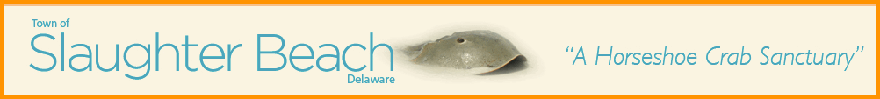

Town of Slaughter Beach Public Notice
Annual Town Council Meeting – June 6, 2026
The Town Meeting will be held in person at 359 Bay Avenue, in the Slaughter Beach Fire Department Dining Hall, and via Zoom – 10:00 am

Join Zoom Meeting
https://us06web.zoom.us/j/9566893059?omn=85181882789

Meeting chat link
https://us06web.zoom.us/launch/jc/85181882789

Meeting ID: 956 689 3059

All Slaughter Beach residents and members of the public are invited to attend.
(Please be advised that this agenda is subject to amendments including additional or deleted items, including Executive Sessions but only additional items of an emergency nature (29 Del. C @ 10004 (e)(1) or with notice at least 6 hours in advance of the meeting and only for items that may not be reasonably deferred to a later meeting). Agenda items may be considered out of sequence.

ORDER OF BUSINESS

- Call meeting to order – 10:00 AM - Harry
- Welcome and Overview of Annual Meeting - Harry

CRITICAL INFRASTRUCTURE

- Government/Town Services
  - Town Election, if required – July 4, 2026 - Ben
- Wastewater/Sewer Project - Bob
- Drinking Water (Artesia) - Joanne
- Public Health/Bay Health Campus - Jamie
- Communications and Energy - Harry
- Information Technology - Jamie
- Emergency Services/Memorial Fire Company – Ben
- Public Access Plan – DNREC - Jamie

PUBLIC WORKS

- DNREC/USACE Sand on the Beach - Bob
- Road Resurfacing - Bob
- Security Cameras - Harry
- Rotating drawbridge project - Jamie
- Coastal Resiliency Design Studio efforts on Marvel - Joanne
- Building Inspection/Floodplain Administration - Ben
- Park and Pavilion upgrades and maintenance - Bob

FINANCE

- Town Financial Position - Jamie
- Court Mandated Tax Reassessment - Jamie

ITEMS OF INTEREST

- Slaughter Beach Historical Society - Joanne
- Slaughter Beach Sail Club - Harry
- Resident Ospreys & Shore birds - Ben
- Delaware Nature Society - Bob
- Beach Maintenance - Joanne
- Seaside Envoy Program – Harry
- Red Knot Festival – Joanne
- Pavilion Reservations - Ben
- To be on the mail list for the town, message townmanager@slaughterbeachde.com
- To be on the mail list for the Sailing Club message 09sbsc@gmail.com

OPEN FORUM DISCUSSION

ADJOURNMENT

Prepared by: Benjamin Monastero, Posted and published: May 30, 2026

Agenda Page 2
https://slaughterbeach.delaware.gov

