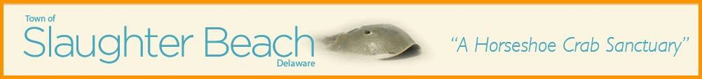

Town of Slaughter Beach Public Notice

Annual Town Council Meeting – June 7, 2025, 10:00 AM

The Town Meeting will be held in person at 359 Bay Avenue, in the Slaughter Beach Fire Department Dining Hall, and via Zoom
All Slaughter Beach residents and members of the general public are invited to attend.
(Please be advised that this agenda is subject to amendments including additional or deleted items, including Executive Sessions but only additional items of an emergency nature (29 Del. C @ 10004 (e)(1) or with notice at least 6 hours in advance of the meeting and only for items that may not be reasonably deferred to a later meeting). Agenda items may be considered out of sequence.
Join Zoom Meeting
https://us06web.zoom.us/j/9566893059?omn=82977029268
Meeting ID: 956 689 3059

ORDER OF BUSINESS
- Call meeting to order
- Welcome and announcements
- Review of the Full Year ending June 30, 2025
  - Real Estate – Harry Ward
  - Beach Grass – Bob Wood
  - EOP - Emergency Operations Plan - Joanne Plescia
  - Seaside Envoy Program - Harry Ward
  - Smart911 and DENS programs - Harry Ward
  - Trash on the Beach, Adopt a Highway – Harry Ward
  - Boardwalk/Osprey – Harry Ward
  - Park Improvements Grant/ARPA Funds - Joanne Plescia
  - Street Resurfacing - Harry Ward
  - Sewer District – Bob Wood
  - Finances – Joanne Plescia
  - Cybersecurity – Jamie Draper
  - Fire Department – Bob Wood
  - New Tax Assessments – Joanne Plescia
  - Annual Town Yard Sale and Large Item Pick Up – Bob Wood
  - Roll Off Dumpsters – Bob Wood
  - Delaware Nature Society – Harry Ward
  - Slaughter Beach Historical Society – Joanne Plescia
  - Pets – Harry Ward
  - July 4th, Slaughter Beach Sail Club Regatta – Harry Ward
  - Council Meetings – Bob Wood
  - Election – Bob Wood
- Adjournment
Prepared by: Julia Geha
Posted and published: May 25, 2025

