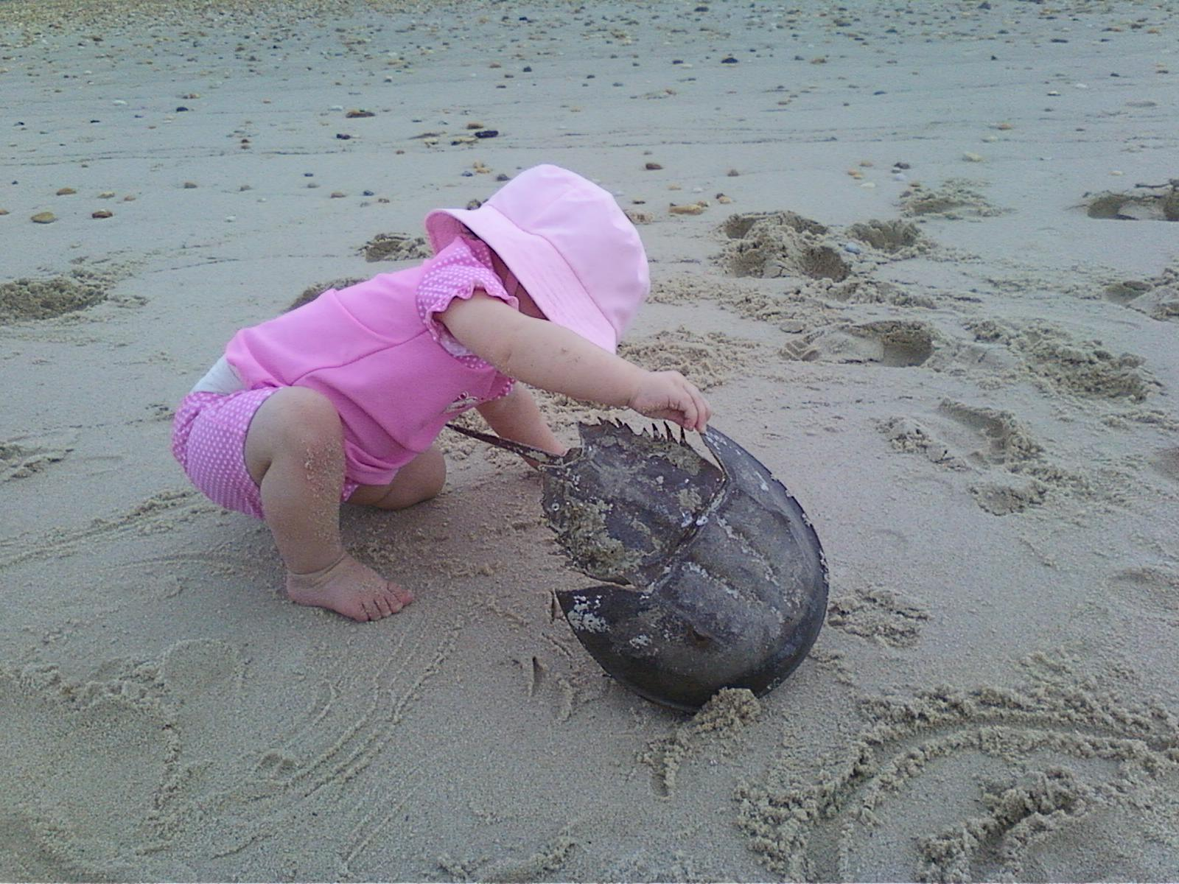

GUIDELINES FOR SAFE FUN

*DRIVING*

The speed limit through town is 25 mph, until you get to the north end where it increases to 35 mph.

*Please watch our children.*

*We have many, but can’t spare any.*

*SWIMMING*

Swim with other people - at your own risk - since there are no lifeguards.

*BOATING*

Boat a safe distance from shore. Consider water depth particularly at the north end of the beach and during low tide.

*JET SKIS*

Ride jet skis a minimum of 100 feet from shore, swimmers, non-motorized boats, and anchored boats.

*PETS*

Keep your dogs leashed and under your control. Remove pet waste and dispose of properly.

*BONFIRES*

When building a bonfire consider wind force and direction along with possible burn bans. Keep fire pits below dunes and extinguish fully by covering with sand before leaving.

*DUNES*

Enjoy strolling the beach looking for special treasures but please stay off the dunes/beach grass as they are fragile and are the first line of protection from flooding.

OUR ENVIRONMENT

As a coastal community we have “visitors” that not all communities get to enjoy. Winter brings Canada and snow geese and the occasional tundra swan. In recent winters, a snowy owl has been gracing our town with its presence. The warming days of April give the baby diamondback terrapins a reason to emerge from the sandy beach and make their way to the marsh. Please, if you see these babies in the yard or on the street, move them to the safety of the marsh. If you happen across an adult terrapin, you can help it cross the road in the direction it was heading. May and June delight us with the spawning season of the horseshoe crab. These creatures are our mascot. They may look menacing but they are docile creatures. If you see one on its back, gently flip it over, but not by its tail. Shorebirds flock to the area, especially red knots to feast and fatten up on the horseshoe crab eggs. The purple martins and hummingbirds are back in full force. Dolphins and cownose rays frolic offshore during the summer months. Fall shows us the migration of the monarch butterflies across the bay. Slaughter Beach is a Certified Wildlife Habitat as of May of 2015, and we are beginning to naturalize our surroundings to help the monarch population, and other wildlife, grow and thrive.

*…A man knows that the world is not given by his fathers, but borrowed from his children…*

Wendell Berry, 1971

We are a small coastal community with great pride and love for our surroundings. There is a laid-back feel to living here. Kids play outside, neighbors wave to each other. Our love of the water and unspoiled nature draws us and keeps us here. Each season brings its own surprises, from snowy owl sightings in winter to horseshoe crab spawning and dolphins playing offshore in late spring and summer.

Welcome! We hope you enjoy and nurture our town and all of its inhabitants as the rest of us do.

*WELCOME*

*to*

SLAUGHTER BEACH

Horseshoe Crab Sanctuary: 2004

Certified Wildlife Habitat Community: 2015

Population: 207

Established: 1681

Incorporated: 1935

*LOCAL HOSPITALS*

MILFORD MEMORIAL - Milford (7 miles.)

100 Wellness Way

(302) 422-3311

BEEBE HOSPITAL - Lewes (19 miles)

424 Savannah Road

(302) 645-3300

KENT GENERAL - Dover (25 miles)

640 S. State Street

(302) 674-4700

*COMCAST*

(800) 266-2278

*DUPONT NATURE CENTER*

992 Lighthouse Road

(302) 422-1329

*STATE OF DELAWARE FISH AND WILDLIFE ENFORCEMENT* - 24 hour hotline

(800) 523-3336

*DELAWARE RECREATIONAL WATER QUALITY HOTLINE*

(800) 922-WAVE

*MAMMAL/ANIMAL STRANDING (MERR)*

[www.merrinstitute.org](http://www.merrinstitute.org)

(302) 228-5029

*SUSSEX COUNTY ANIMAL CONTROL (Dogs/Cats)*

(302) 255-4646

*FORGOTTEN CATS (cat rescue organization)*

[www.forgottencats.org](http://www.forgottencats.org)

(302) 429-0124

*IMPORTANT WEBSITES*

State of Delaware: [*www.delaware.gov*](http://www.delaware.gov)

Sussex County: [*www.sussexcountyde.gov*](http://www.sussexcountyde.gov)

DNREC: [*www.dnrec.delaware.gov*](http://www.dnrec.delaware.gov)

Delaware Emergency Management Agency [*www.dema.delaware.gov*](http://www.dema.delaware.gov)(Evacuation Info)

KEEPING UP-TO-DATE

To be placed on our town email list and receive emergency information and public notices, please provide us with your name, street address, telephone number and e-mail address at:

[slaughterbeachsignup@comcast.net](http://slaughterbeachsignup.comcast.net).

**Please Note: For more information regarding our town please go to our town website**

[**www.slaughterbeach.delaware.gov**](http://www.slaughterbeach.delaware.gov)

OTHER IMPORTANT CONTACT INFO

*SUSSEX COUNTY EMERGENCY MANAGEMENT 911 PHONE REGISTRATION*

Please register your mobile or out of town phone number to receive emergency and evacuation information (302) 855-7801

*SLAUGHTER BEACH MEMORIAL FIRE CO*

(302) 422-8888 - non-emergency

*STATE POLICE*

(302) 644-5020 - non-emergency

Our town falls under the jurisdiction of

DE State Police Troop 7 in Lewes, DE

*SCHOOL DISTRICT*

Milford School District

906 Lakeview Ave

(302) 422-1600

*DELMARVA POWER*

(800) 375-7117 - Customer Service

(800) 898-8045 - Power Outage

*ARTESIAN RESOURCES WATER CO.*

(800) 332-5114 – Emergency

(302) 453-6900 – Customer Service

(302) 232-5460 – TDD

Email: custserv@artesianwater.com

*MOSQUITO CONTROL*

Please contact the Councilperson listed on the Slaughter Beach website

TOWN GOVERNMENT

Slaughter Beach is governed by a five member elected town council. Town Council meetings are held on the 2nd Monday of each month at the Fire Hall on the 2nd floor, southeast entrance. Elections are held on the first Saturday in July, if needed.

TRASH PICKUP

Mondays - usually early AM

Recycling - every other Monday early AM

Pleasesee our website for more info

TOWN CONTACT INFO

*TOWN OFFICE*

(302) 424-7659 - leave message

[townofslaughterbeach@comcast.net](mailto:townofslaughterbeach@comcast.net)

The unstaffed office is located on the second floor of the Fire Hall at

359 Bay Avenue.

*ZONING CODE OFFICIAL*/*FLOODPLAIN ADMINISTRATOR*

Contact before starting any construction

Bob Clendaniel

(302) 270-0687

zoningofficial@slaughterbeachde.com

*TAX COLLECTOR*

Angela Tibbitt (302) 424-1127

taxcollector@slaughterbeachde.com

*TOWN CLERK*

Kathy McFadden (609) 658-0165

townclerk@slaughterbeachde.com

*TOWN COUNCIL*

*C*urrent contact info for the Council is provided on the town website.